3.AWS EC2 deployment
  - Launch EC2
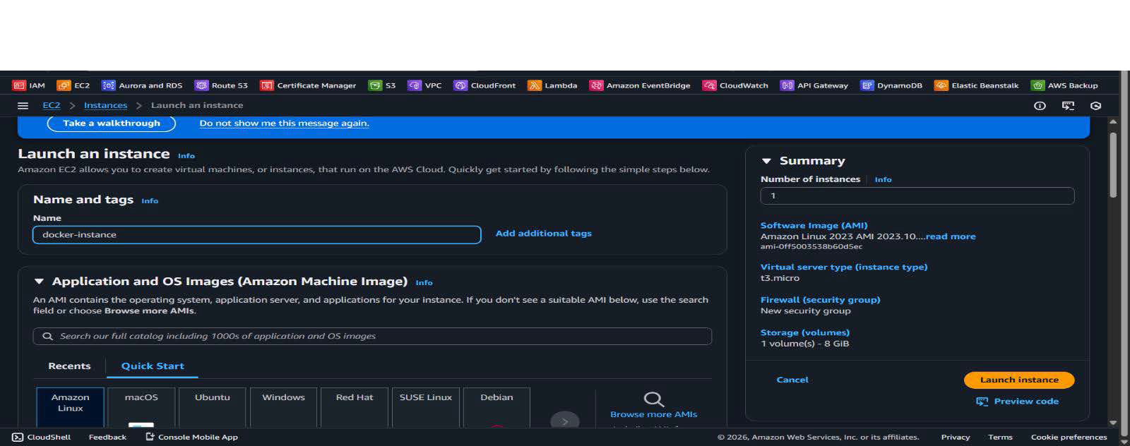
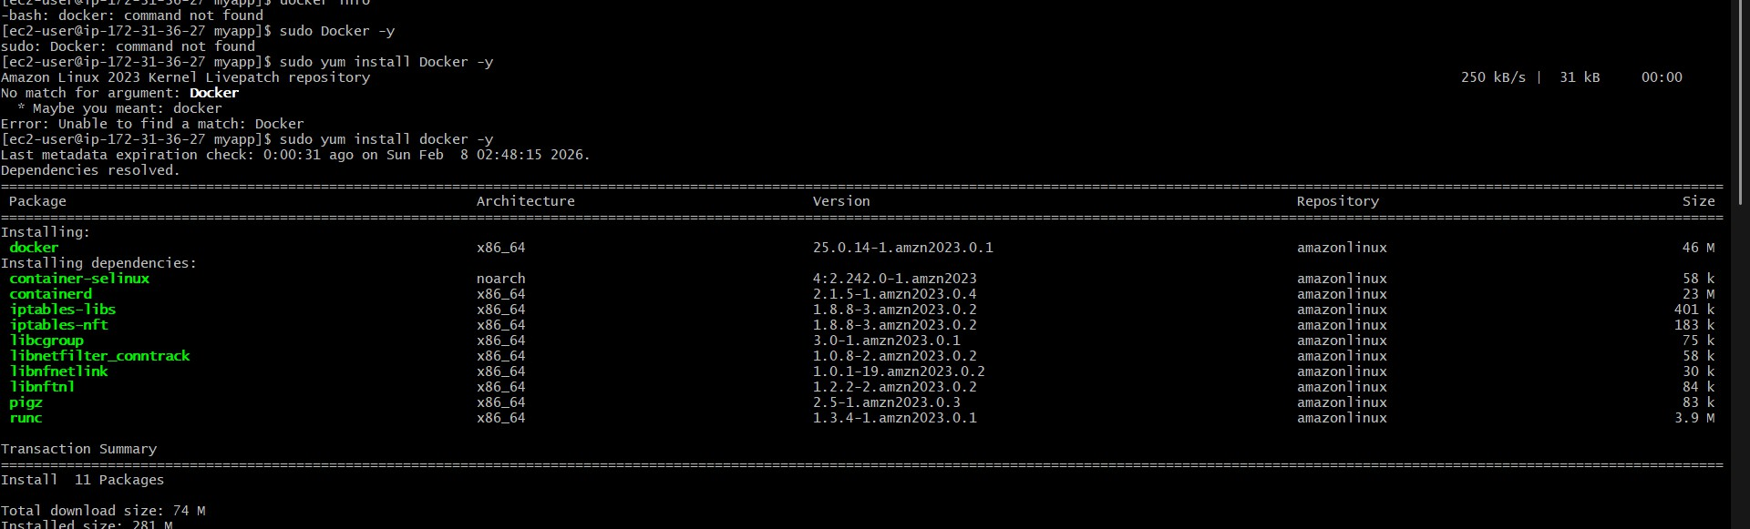
  - Install Docker

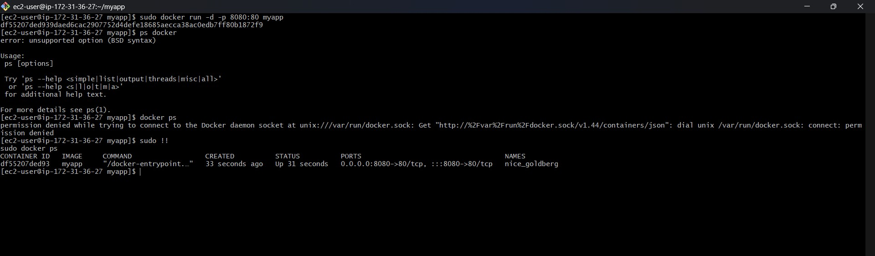
  - Run containers on ec2

